Graph Neural Networks for Social Network Pattern Detection

1. ABSTRACT
Graph Neural Networks (GNNs) are machine learning models that analyze graph structures using deep learning techniques by capturing both node feature information and relationship information among nodes. GNNs use node feature vectors along with an adjacency matrix to aggregate information on neighbors and create embeddings. Graph Convolutional Networks (GCNs) aggregate through weighted matrix multiplication, whereas Graph Attention Networks (GATs) enhance the process by weighting neighbors according to attention coefficients.
Applications of GNNs include anomaly detection, industrial process monitoring, social networking applications, and large group decision-making processes. Deep learning models in Industrial Anomaly Detection (IAD) increase productivity as well as improve detection rates, which can exceed 97% in some cases. Dynamic social networks use GNNs to model user interactions and trust relationships, which are then clustered into decision-making groups using K-Means and learned node embeddings.
For implementation purposes, PyTorch Geometric library was used alongside the popular Zachary’s Karate Club dataset for community detection with GCNs. The model was trained using multiple graph convolution layers, resulting in learning relationships among nodes and a classification rate of 100%.
Keywords: Graph neural network, machine learning, clusters, precision, embeddings, attention, image, point, anomaly.
2. INTRODUCTION
  - Graph neural networks
Graph neural networks (GNNs) are a deep neural network architecture that is popular both in practical applications and cutting-edge machine learning research [1]. They employ a neural network architecture to capture information regarding entities and the connections between them, as in Fig 1.
Each node in the graph can be described with a node feature vector (i.e [0.4, 1, 0, 1.3]). For a molecule, this feature vector would contain information about the atoms. For a social network, attributes about a person, regarding the structural information of the graph, we have the adjacency matrix; it tells us which nodes are connected.

Fig 1. Neural network model
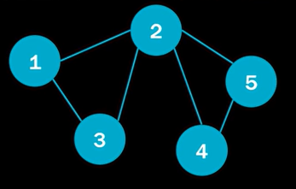
The node features are stacked into a matrix. It contains the nodes (from h1…h5) and features per node, as in the below Fig 2. :
Fig 2. Matrix nodes Fig 3. Node embedding update Fig 4. Shared weight matrix
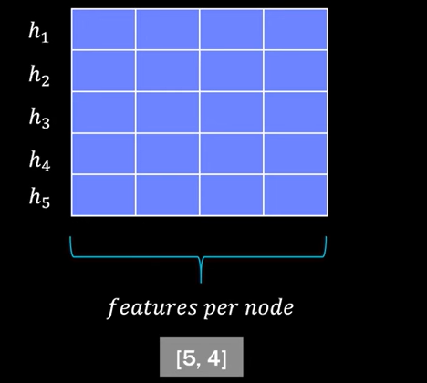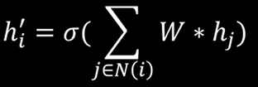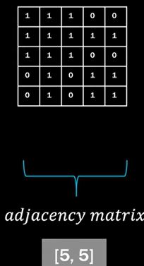
Fig 3. above shows the formula which, for graph neural networks, describes the update of a single node embedding. We transform the node features by multiplying them with a shared weight matrix, as in Fig 4. This learnable linear transformation converts the node features into higher-level ones.
Fig 5. The weight matrix where the learning takes place
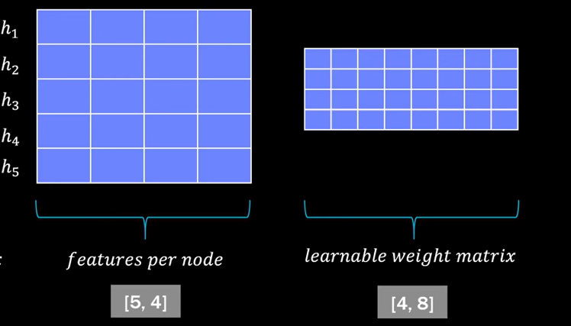
Learning takes place in the weight matrix of a fully connected neural network with an input size of 4 and output size of 8 nodes in the embedding vectors (Fig. 5). Node features get processed using a single layer neural network, which mainly emphasizes neighbors whose sum is used to create an embedding. Summing is done using a mathematical equation, where i represents the current node while j represents its neighbors. By use of the adjacency matrix, which is 5 x 5, summing of messages from neighboring nodes becomes automatic. New embeddings that incorporate both node and neighbors features are generated at the end (Fig. 6). Each layer changes the size of embeddings by use of matrix multiplications, specifically through a weight matrix. Multiplication with the adjacency matrix makes sure that only connected neighbors get used (Fig. 7)
Fig 6. First row of adjacency matrix Fig. 7. Node 1 is not connected to nodes 4 and 5
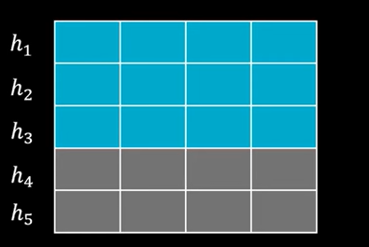
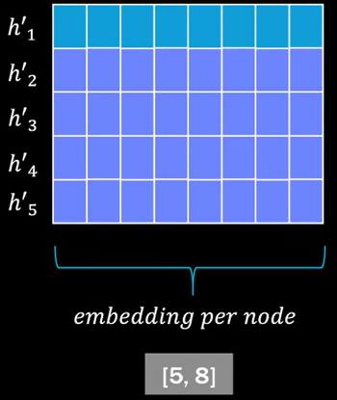
This means we’re left now with the sum of these transform node features of node 1,2,3. By looking into Fig. 8., this is what goes into each of our updated node embeddings, so h*1, h*2, h*3, etc. They build the new embedding for node 1.
Fig 8. Updated node embeddings
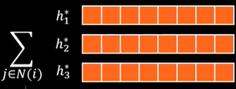
But how can this process be extended with the attention mechanism?
2.2 Graph attention networks
GAT’s (graph attention networks) are a popular variant of GNN’s (graph neural networks), which were presented by Veličković et al. in 2018 and they leverage attention mechanisms for feature learning on graphs [2]. They offer a more nuanced approach to aggregating neighborhood information compared to traditional GNNs.
The attention in neural networks is to learn how important the node j’s features are for a node i, This information is called the attention coefficient (Fig. 9).
Fig 9. Attention coefficient Fig 10. Weight for each edge of neighbors
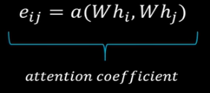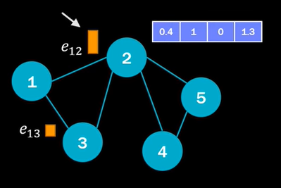
We can see it as a weight for each edge of the neighbors; it tells us how much attention we should pay to that specific node. Fig. 10. aims to validate that.
The model should pay more attention to node 2 when aggregating those new embeddings. It is obvious in e₁₂ that the attention is bigger in e₁₂ rather than e₁₃ due to the higher vertical bar that indicates the sign of attention. It’s used commonly in NLP (natural language processing) and used in many state-of-the-art models such as transformers. Text data in machine learning is usually modeled as a sequence of words and the words are represented as word vectors.
Fig 11. The importance of word “i” to word “j”
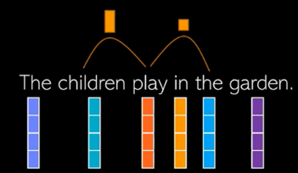
The GAT’s role or the attention is to learn the relationship between different words, which means how important the word i to the word j is (Fig. 11). In NLP, the word "children" takes precedence over "the" in "play" when assigning attention coefficients to incorporate context into word vectors. The field of NLP shares similarities with geometric deep learning on graphs. In attention models, node feature vectors are modified using weights that determine their relevance.
If we calculate these attention coefficients we might get very different values for different nodes.
3. LITERATURE REVIEW
Discovering Unknowns: Context-enhanced Anomaly Detection for Curiosity-driven Autonomous Underwater Exploration
Automated discovery of submerged objects by making use of autonomous underwater machine learning involves the use of anomalies detection for discovering objects that have not been seen before. The process involves the application of image reconstruction through the use of autoencoders, autoregressive models, and patch learning. Anomalies can be measured using scores and conditional probabilities.
Self-supervised anomaly pattern detection for large scale industrial data
The use of data-based approaches in industries has been noted in recent times where emphasis is placed more on trends of data than models, but where subsystems are isolated negatively.
Anomaly detection for global monitoring data requires the implementation of plant-wide monitoring. Companies need to design plant-wide performance indicators (PWPI) and evaluate the impact of data anomalies on these global indicators [4].
DB-KIT assesses anomalies via performance detection, prioritizing parity, while parametrized residual generators and HMMs enable multi-objective detection and CSAE aids.
Deep Industrial Image Anomaly Detection: A Survey
The problems are IAD applicability and that although memory bank algorithm works well for images, ensembling works best. There is no much difference between few-shot learning and the conventional method, and both require segmentation to detect anomalies.
The aim of the IAD algorithm is to minimize human labor and increase productivity and quality. Prior to deep learning, the efficiency of the IAD was insufficient for industrial manufacturing. Nowadays, the deep learning method has received good results, and most of these methods are more than 97% accurate [5].
4. RESEARCH GAP
Limited scalable models for large-scale social graphs
Applicability of IAD problems are there; ensembles perform better than memory banks, while both learning approaches require segmentation for anomaly detection. This is also the second sentence that comes after the first sentence here.
Group Decision Making (GDM): Group decision-making or GDM refers to the procedure whereby some individuals make decisions as a group.
Dynamic Social Network (DSN): A dynamic social network or DSN is a form of dynamic network whose nodes (individuals/agents) and links (social relations) change dynamically.
Large-Scale Group Decision-Making (LSGDM): LSGDM is a branch of GDM which focuses on situations where a lot of decision-makers are involved (hundreds to thousands).
The method consists of a five-step process of building a dynamic social graph, where GNN is used to learn features for nodes, clustering individuals into decision making groups, and finally aggregating decisions for consensus extraction within groups.
Phase 1: Constructing the dynamic social graph
We model the social environment as a Dynamic Graph= G(V,E,T) where: V denotes the set of decision-makers (users), E represents edges denoting social relationships (trust/distrust), T captures temporal snapshots reflecting the evolving nature of the network [7].
The parameters that each edge e_{ij} belongs to set E is given as follows: Trust value t_{ij} ∈ [ −1, 1], Cosine similarity of user preferences, Interaction frequency & recency, and Triadic closure. This constitutes structural as well as semantic parameters.
Phase 2: Clustering users into decision-making groups
Clustering of the users is done using the learned embedding vectors {ℎi} based on K-means, thus dividing them into subgroups according to how similar their decisions are semantically. These clusters represent micro-communities where intra-group consensus is likely to be more stable [9].
Fig 12. Input: A set of user embedding vectors:
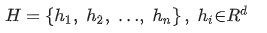
Each ℎi represents the embedding vector of the user i in d dimensions, obt5ained using the trust relations of each user. We use K-Means clustering owing to its scalability and interpretability in large-scale consensus systems. The optimization function is represented in the downward photo:
Fig 13. The optimization function
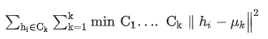
, where C_{k} is the set of all users in cluster k, μ_{k} is the centroid of cluster C_{k}, and Optimal K Estimation: Silhouette Coefficient. To determine the optimal number of clusters K, we use the Silhouette Coefficient, which measures both cohesion and separation [10].
Fig 14. The Silhouette score for user i
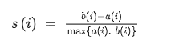
a(i) denotes the average distance of i from all other points belonging to the same cluster, while b(i) represents the minimum average distance of i to all points in another cluster (nearest cluster). Global Score:
Fig 15. Global score
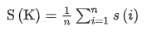
The following formula is selected:
Fig 16. K-star algorithm to find the k shortest paths
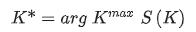
The output is a K-user-group set:
Fig 17. K-user groups
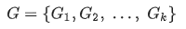
In the next step, each group G_{k} is analyzed to calculate intra-group consensus.
The benefits associated with this stage include a reduction of the level of complexity involved with the process of aggregation from O(n) to O(K∗), enhancing group consensus and increasing fairness.
Phase 3: Global Group Consensus Aggregation
The GCD-GNN combines the group interactions based on the local consensus vectors, which perform better than seven other methods.
The empirical findings show that the suggested GCD-GNN continuously performs better than baseline techniques in terms of the accuracy, precision, and consensus quality of the combined group decisions [12].
This algorithm provides outstanding scalability and efficiency when used in large social networks, thanks to local message passing, which helps achieve consensus even with changing interactions between individuals making decisions.
5. CONTRIBUTIONS
Deep learning on graphs has become one of the most exciting areas of study within the realm of deep learning. Graph Neural Networks (GNNs) aim to generalize classical deep learning concepts to irregular structured data (in contrast to images or texts) and to enable neural networks to reason about objects and their relations [13].
The project began with setting up the work environment and installing required packages and get the torch version to work with PyTorch. To include matplotlib graphs in the notebook, %matplotlib inline was used, since it is a library to create visualizations in Python. The library networkx was used to study the graphs and networks, and plt, a pyplot package "pyplot" from the library "matplotlib" was also utilized. A method, visualize_graph, constructs a visual representation of the graph based on the data about it. To further use the PyTorch features, the pip install torch_geometric command is run in the code.
Techniques to implement the KarateClub class are frequently infeasible, but KarateClub(), the library to detect communities and embed networks based on the Karate Club event, has all the necessary characteristics to use the components of the KarateClub and to show the original Karate Club problem, which is outlined below.
A social network of a karate club was studied by Wayne W. Zachary for a period of three years from 1970 to 1972. The network captures 34 members of a karate club, documenting links between pairs of members who interacted outside the club [14]. While conducting the experiment, there was a dispute between the manager named "John A" and the trainer "Mr. Hi" (pseudonyms). As a result, the club broke apart into two separate organizations. One-half of the club's participants joined the organization that supported Mr. Hi; the others either changed their instructor or stopped practicing karate. Using the gathered information, Zachary made an accurate prediction for all except one member of the club. In this case, our focus is on identifying communities formed based on such interactions.
The node numbered 1 represents the instructor and node 34 the club administrator/president. The membership was segmented into four communities; one for John A, one for Mr. Hi, one community battled with the decision of which club to join, and the others quit the practice [15].

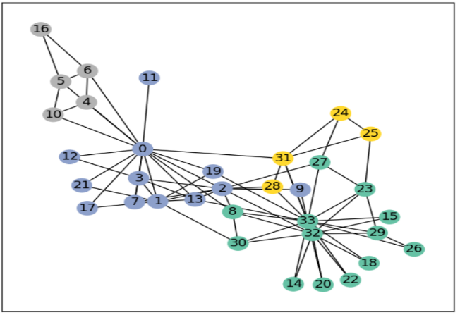
Fig. 18. Zachary’s karate club
The image part of the Figure 18 uses the library to_networkx to make a networkx graph given the data structure of graph. It ensures that the graph is converted to an undirected one, and colors are the y-components of the graph data, which are used to represent 1 community for each color.
The train_mask represents only the nodes for which communities are known(4 of them, hence 4 True's); the nodes with "True" are part of the training set and the others part of the testing set, so this division of data helps by providing data not seen before by the model for testing). As mentioned before, the train_mask represents only the nodes for which communities are known(4 of them, hence 4 True's); the nodes with "True" are part of the training set and the others part of the testing set, so this division of data helps by providing data not seen before by the model for testing.
After the data handling part of PyTorch Geometric (PyG), the Graph Neural Network implementation is shown in the next lines of code. For this, we will use on of the most simple GNN operators, the GCN layer, which is defined as
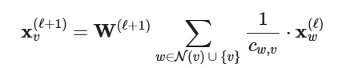
Fig. 19. GCN layer formula
W(l+1) denotes a trainable weight matrix of shape [num_output_features, num_input_features] and C_{w,v} refers to a fixed normalization coefficient for each edge. PyG implements this layer via GCNConv, which can be executed by passing in the node feature representation x and the COO graph connectivity representation edge_index.
The Graph Convolutional Network has a single GCN layer, a ReLU activation function, and a linear output layer, as pointed in Fig.20. The output layer will produce four outputs, representing the four classes, and whichever one has the highest output value decides which class the node belongs to. The relu() activation function is used; the linear transformation is applied to the GCN layer.
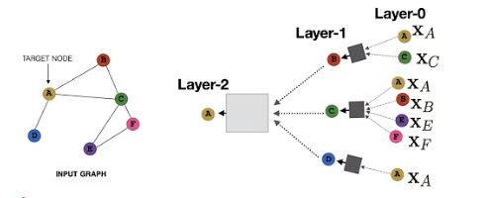
Fig. 20. GCN layer
We first define and stack three graph convolution layers, which corresponds to aggregating 3-hop neighborhood information around each node (all nodes up to 3 "hops" away); the hops represent the maximum number of movements that the information can go from a node to another. In addition, the GCNConv layers reduce the node feature dimensionality from 34 to 3.
After that, we apply a single linear transformation, torch.nn.Linear, that acts as a classifier to map our nodes to 1 out of the 4 classes/communities. We proceed to initialize our final model via GCN().
Data will be appended for the graph animation to show the predictions of the GNN during the training process. Metrics will be printed every 10 epochs, and the results are shown every 20 of them, as in Table 1:
Epoch | Loss | Accuracy
0 | 1.58 | 14.71%
20 | 1.13 | 35.29%
40 | 0.81 | 70.59%
60 | 0.4 | 79.41%
80 | 0.19 | 100%
100 | 0.1 | 100%
120 | 0.07 | 100%
140 | 0.05 | 100%
160 | 0.03 | 100%
180 | 0.03 | 100%
200 | 0.02 | 100%
Table 1. Evaluation of metrics with training data
The regular cross-entropy method used for multi-class classification task. We aim to evaluate the accuracy of the model based on the formula: accuracy= number of correct predictions/ total number of predictions.
Figures 21 and 22 show nodes at different epochs and accuracies. Accurately classified nodes are the ones of epoch 190, but the process of classification begins at earlier epochs with increasing accuracy.
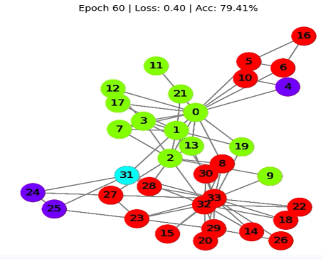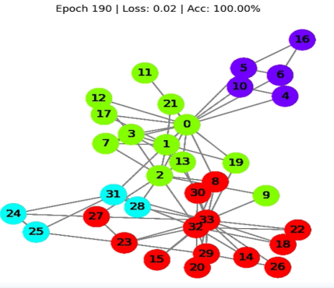
Fig. 21. Nodes at epoch 60 Fig. 22. Nodes at epoch 190
Dimensions of embeddings (34) and feature vectors (4) do not need to be the same; the reduction of dimension from 34 to 3 is to get a 3D visualization of the outcome.
Here, we observe each and every node from the karate club dataset with their actual label information and not by the prediction of the model. At the current stage, all these nodes are located anywhere because the GNN network is untrained. However, if plotted step-by-step during the training process with the test data, we could actually observe the learning of the GNN. For that, a 3D model shows the results again at epochs 0 (the least accuracy) and 190:
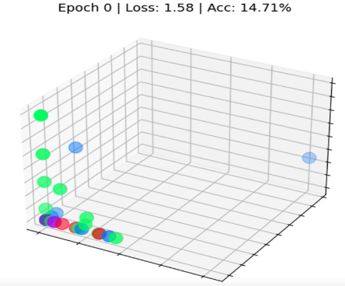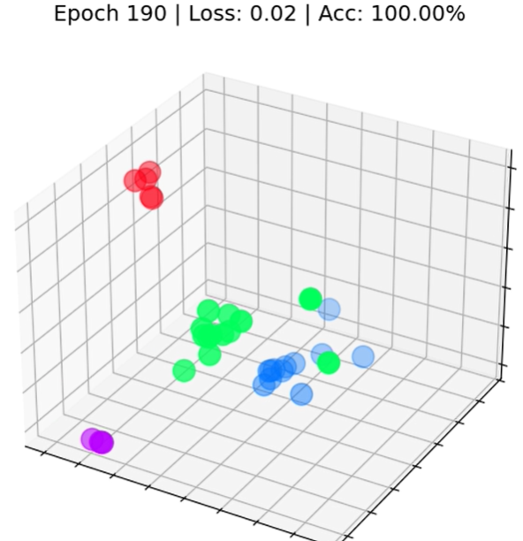
Fig. 23. 3D-nodes at epoch 0 Fig. 24. 3D-nodes at epoch 190
In standard neural networks, linear layers perform linear transformations on the inputs. These linear transformations map the input features x into the hidden vector h using the weight matrix 𝐖. Disregarding the presence of biases, this is done using the equation
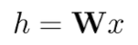
Fig. 25. Weight matrix equation
In graph analysis, there is an extra layer of complexity because of the connections between the nodes. Such a connection is important because usually it is perceived that nodes with similarities have higher chances of being connected than nodes without similarities. This process is referred to as network homophily.
This was done by combining information about the node and its neighborhood nodes together. This is referred to as convolution or neighborhood aggregation. Let us denote the neighborhood of node i along with itself as Ñ.
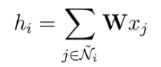
Fig. 26. Neighborhood of node i with itself
Our weight matrix W, however, stands out from those used in CNNs in that it is specific to our neural network and common to all nodes. Nevertheless, there is another problem: nodes do not have a fixed number of neighbors like the pixels.
What about situations when one node will have only one neighbor while another has 500? The difference is that while adding up all vectors will provide us with a larger vector h for the node which has many neighbors, we should normalize it according to their degree in order to get comparable results for all nodes.
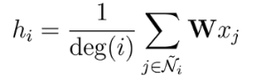
Fig. 27. Formula to normalize vector to the degree of its neighbors
It was found that features of nodes having many neighbors spread much more easily than features of less connected nodes. In order to balance this tendency, it was recommended that features of nodes having few neighbors be weighted higher. This procedure can be described by the following formula:
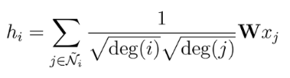
Fig. 28. Weighing the nodes that have fewer neighbors higher
Adding another GCN layer will enable us not only to sum the feature vectors of the neighbors of each node, but also of the neighbors of its neighbors.
We can stack many layers and aggregate even more distant values, however, there’s a drawback, adding more than a certain number of layers will make us over smooth everything, and as a result, all of the embeddings will be very similar to each other.
Initial predictions are just guesses, but the predictions made by the GCN are perfect for all nodes after some time. But what is the GCN learning?
In our network, the GNN takes features from neighboring nodes and produces embeddings for each node. Then, the final layer learns how to utilize these embeddings in order to come up with the most accurate predictions. Embeddings, therefore, are the true output of GNNs.
6. LIST OF TABLES, FIGURES, AND REFERENCES
6.1 List of Tables and Figures
Fig 1. Neural network model……………………………………………………………………………1
Fig 2. Matrix nodes………………………………………………………………………………………2
Fig 3. Node embedding update…………………………………………………………………………2
Fig 4. Shared weight matrix…………………………………………………………………………….2
Fig 5. The weight matrix where the learning takes place…………………………………………..2
Fig 6. First row of adjacency matrix……………………………………………………………….....2
Fig 7. Node 1 is not connected to nodes 4 and 5…………………………………………………….2
Fig 8. Updated node embeddings………………………………………………………………….…..3
Fig 9. Attention coefficient…………………………………………………………………………...…3
Fig 10. Weight for each edge of neighbors…………………………………………………..……….3
Fig 11. The importance of word “i” to word “j”……………………………………………………3
Fig 12. Input: A set of user embedding vectors………………………………………………….…..5
Fig 13. The optimization function…………………………………………………………...………...5
Fig 14. The Silhouette score for user i………………………………………………………...……...6
Fig 15. Global score………………………………………………………………………………….....6
Fig 16. K-star algorithm to find the k shortest paths…………………………………………...…..6
Fig 17. K-user groups…………………………………………………………………………..….……6
Fig 18. Zachary’s karate club………………………………………………………………………….7
Fig 19. GCN layer formula…………………………………………………………………………….13
Fig 20. GCN layer………………………………………………………………………………………13
Fig 21. Nodes at epoch 60………………………………………………………………….....………..9
Fig 22. Nodes at epoch 190………………………………………………………………….…………9
Fig 23. 3D-nodes at epoch 0…………………………………………………………………………..10
Fig 24. 3D-nodes at epoch 190………………………………………………………….…………….10
Fig 25. Weight matrix equation……………………………………………………………..…………10
Fig 26. Neighborhood of node i with itself………………………………………………….……….10
Fig 27. Formula to normalize vector to the degree of its neighbors………………….………….11
Fig 28. Weighing the nodes that have fewer neighbors higher…………………………….……..11
Table 1. Evaluation of metrics with training data……………………………….………………….9
6.2 References
[1] Noble, Joshua. “What Is a Graph Neural Network.” IBM, 18 Feb. 2026, www.ibm.com/think/topics/graph-neural-network.
[2] Veličković, Petar, et al. “Graph Attention Networks.” arXiv.Org, 4 Feb. 2018, arxiv.org/abs/1710.10903.
[3] Discovering Unknowns: Context-Enhanced Anomaly Detection for Curiosity-Driven Autonomous Underwater Exploration - Sciencedirect, www.sciencedirect.com/science/article/abs/pii/S0031320322003417. Accessed 4 May 2026.
[4] Cohen, Ira. “What Is Anomaly Detection?” Anodot, 9 Sept. 2025, www.anodot.com/blog/what-is-anomaly-detection/.
[5] Ahmed, Shams Forruque, et al. “Deep Learning Modelling Techniques: Current Progress, Applications, Advantages, and Challenges - Artificial Intelligence Review.” SpringerLink, Springer Netherlands, 17 Apr. 2023, link.springer.com/article/10.1007/s10462-023-10466-8.
[6] Scalable and Adaptive Large-Scale Group Decision Making in Dynamic Social Networks via Graph Convolutional Neural Networks# - Sciencedirect, www.sciencedirect.com/science/article/pii/S2667305325001462. Accessed 5 May 2026.
[7] Kridera, Stavroula, and Andreas Kanavos. “Exploring Trust Dynamics in Online Social Networks: A Social Network Analysis Perspective.” MDPI, Multidisciplinary Digital Publishing Institute, 15 May 2024, www.mdpi.com/2297-8747/29/3/37.
[8] Knowledge Enhanced Graph Neural Networks 1st Luisa Werner, arxiv.org/pdf/2303.15487. Accessed 6 May 2026.
[9] Lancichinetti, Andrea, and Santo Fortunato. “Consensus Clustering in Complex Networks.” Nature News, Nature Publishing Group, 27 Mar. 2012, www.nature.com/articles/srep00336.
[10] Silhouette Coefficient - an Overview | Sciencedirect Topics, www.sciencedirect.com/topics/computer-science/silhouette-coefficient. Accessed 6 May 2026.
[11] Peijin Yu Graduate School of Information Science and Electrical Engineering, et al. Leveraging the Dynamics of Leadership in Group Recommendation Systems, arxiv.org/html/2503.12877. Accessed 6 May 2026.
[12] (PDF) SVD-GCN: A Simplified Graph Convolution Paradigm for Recommendation, www.researchgate.net/publication/364444023_SVD-GCN_A_Simplified_Graph_Convolution_Paradigm_for_Recommendation. Accessed 6 May 2026.
[13] Sanchez-Lengeling, Benjamin, et al. “A Gentle Introduction to Graph Neural Networks.” Distill, 8 Sept. 2021, distill.pub/2021/gnn-intro/.
[14] “Zachary’s Karate Club.” Wikipedia, Wikimedia Foundation, 22 Oct. 2025, en.wikipedia.org/wiki/Zachary’s_karate_club.
[15] McPherson, LeMark. “The Fission of Zachary’s Karate Club.” Information Visualization, 7 July 2020, studentwork.prattsi.org/infovis/visualization/zacharys-karate-club-2/.

